Thursday, June 29th | $19.00
Mystic Cinemas | The first trip of the summer is a quick trip to the movies! Campers will be traveling to Mystic Cinemas to see the new children’s movie, Elemental. Campers will receive a complimentary bag of popcorn and a juice box!
Wednesday, July 12th | $18.00
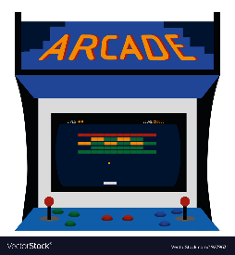  Treehouse Arcade | Campers will be given fully loaded play cards to play any arcade game they can imagine. This arcade includes claw machines, Pac-man, racing games, and so much more. All games are eligible to earn tickets, which campers will be able to exchange at the end of the trip!
Wednesday, July 19th | $17.00
Strawberry  Park | One of our favorite field trips is back!!! Campers will be heading to Strawberry Park where they will get to swim in a poll, play in a Splash pad, go on the playground, and have access to the basketball court for a fun day in the sunshine!
Wednesday, July 26th | $5.00
Kayaking  at  Long Pond | Campers will be heading to Long Pond Lake to go Kayaking! While they wait their turn to have some fun in the water they will be educated on the Lake and the plants that grow in it. Groups will be assigned and rotated between camp all day so those dodgeball lovers can still play!
Wednesday, August 2nd | $25.00
CT  Science  Center | As their final field trip of the year, Colonels will be going to the CT Science Center where they can have fun with all kinds of activities, ranging from exhibits and history to building blocks and making science happen!

