Super Colonels Staff 2016

Coordinator:
Brittany Littlefield
Typically referred as “Applesauce,” Brittany has been working for Parks and Rec for the past 9 summers, which is like forever to her. Her favorite animal is a giraffe because she can relate to them on a height level. On any given day, you can find her playing knockout, attempting arts and crafts, and killing to friendship bracelet game.
Leaders:
Greg Knight
Greg is a Masters student in UCONN’s school of education. This summer is his 7th summer working at summer camp! He is the 2007 world champion 4-square player, and is reigning 2015 Super Colonels water pong champion. He also enjoys camp games such as kingpin dodgeball, capture the flag, and ultimate frisbee. He is a diehard New York Giants (I mean, Patriots) fan who looks to have a fantastic year at the Super Colonels camp!
Jessica Monday
This is Jess’s 6th year working with Ledyard Parks and Recreation and her 3rd year as a leader. She is going into her senior year at Colby-Sawyer College to receive her degree in athletic training and obtain her coaching certificate.

Counselors:
Owen Wheeler
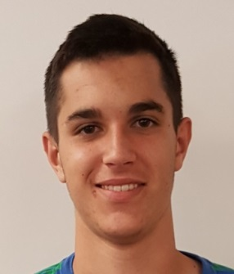
Hi I'm Owen Wheeler. While growing up in Ledyard, Connecticut , I decided to learn the French language so I could speak to my French-Canadian family . After 5 years of learning French , trust me I can say more than Oui Oui and Bonjour. As I've gone to Ledyard High School, I've played many sports. However, my favorites are baseball and soccer, the two sports that everybody doesn't like watching because they are "too slow" and "boring" ; well besides golf. Other than sports, I am the king of Four Square (Even though I'm always the ace). Also, I'm not a binge watcher, but I am a movie fanatic. I'm always looking for a good movie to watch, whether it's a Horror movie with scary clowns or a Romantic drama like The Notebook. In the winter, when I'm not watching movies I am skiing. I'm a pretty good skier, but I still don't understand it when I see a bunch of 9 year-olds racing down a double-black diamond like it's a bunny slope. Whether it's hiking, traveling, or skiing, I am always seeking an adventure in life.

Jared Reeves
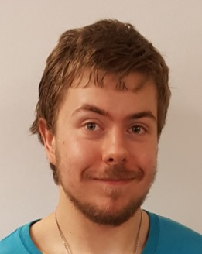
The name's Reeves, Jared Reeves.
When I am not busy working hard in the classrooms and earning honors, I can be found writing new music and prepping for an amazing summer! I love the outdoors and sunny days and hot weather and summer in general. I've been waiting all year to get back to the park to pick up where we left off, making fun memories that last a lifetime!! I've been a member of the Ledyard football and wrestling teams, avid poet on the Inner Visions High school art gallery, and ambitious baker at Big Y. I have tons of ideas for games and activities, and can't wait for a safe, exuberant, and unforgettable summer!!!

Aaron Norcia
Aaron was born and raised in the lovely town of Ledyard. Growing up, Aaron liked to go outside and play. Aaron loved playing outside so much that his mom decided to send him to Blonders to be a part of the playground program. Here he learned that counselors were the coolest people ever! Aaron also learned that it isn’t okay to jump off the top of the slide because doing so will result in an immediate sentence to the bench! Now, Aaron is graduating LHS and going on to study physical therapy at Sacred Heart University in Fairfield, CT. Aaron looks forward to having an excellent summer at Parks and Rec before losing his mind at college.

Claudia Jackson
Claudia Jackson fits right in at camp and if not for the staff shirt, she could easily be mistaken for a camper. She is a frequent prisoner of the camp jail, and has a side job as a private investigator where she periodically searches for lost lunchboxes, water bottles, Waldo, and dodge balls. As a second year staffer, she's really excited to get two more staff shirts (no more doing daily laundry) and is even more excited for another great summer.

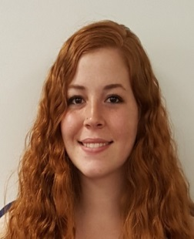

Particia “Trish” Elliot
This is Trish’s 4th year working for Ledyard Parks and Recreation. She is currently a senior in college studying psychology and wants to work with children further in the future. She can be found at camp making a ton of cool arts and crafts.

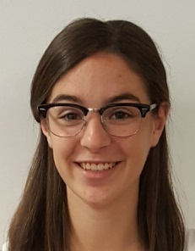
Emme Cronin
This is Emme’s 5th year at Parks and Rec. She currently attends Mount Holyoke College and runs track and cross country. When not at camp, she can be found on her farm rounding up her escaping goats. She sets the fashion trends at camp by wearing her cat embellished bucket hat every day to protect her from the sun. Emme is excited to have another great summer!

Rebecca “Becca” Schmahl
I’m Becca I’m 19 years old and this is my first year at Summer Camp. I will be a junior at Cornell University in the fall. I was a cheerleader and played softball in high school and I am now on a volleyball team. I am really excited for this summer and all the fun we are going to have!

