Colonels Camp Staff 2016:
Coordinator:
Jade Huguenot
Jaderade’s first summer with Ledyard Parks and Recreation was waaaay back in 2000! Her brother, Dustin, spent 5 years as an employee here after she left, but since her return in 2013 she’s been continuing the legacy! She’s studied at UConn, Smith College, and Mount Holyoke College (but sadly, didn’t run into Emme, a Super Colonels Playground Assistant). She has a decade of experience making up songs with kids in accredited institutions; grew up as a Navy brat; is loving the Euro Cup so far; and has a sheltie who she taught to give double high fives. She can’t wait to meet the new Colonels campers this summer and host her first ever Movie Trivia Gameshow with them!
Leaders:
Francesca Francischelli
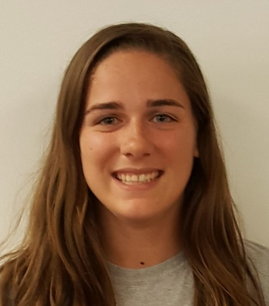
Francesca is currently attending UCONN to become an elementary school teacher and during the summer she works at the camp as a counselor and now as a leader. She is an avid dodgeball fanatic with the campers and can always be found with gimp in her hands. She is known for creating the chicken nugget game last year at the Colonels camp and will continue to create new games. Camp is one of her favorite things to do during the summer because all of the campers there are so amazing and have great personalities. Being a leader at Parks and Rec summer camp doesn't feel like a job to her, She has so much fun being their leader and looks forward to camp every year!
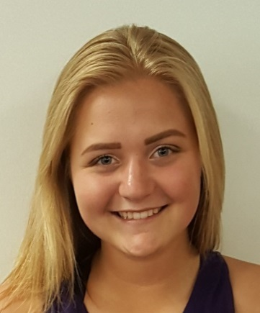
Amy Knight
This is Amy Knight’s 6th year with Parks and Rec and her 2nd year as a Playground Leader. She is an LHS graduate and currently studies Psychology at the University of Pittsburgh as a junior. She is addicted to making gimp and friendship bracelets. Ledyard Center is where she went to elementary school and so she seriously loves working here because it brings her back to her golden years as a child. Amy is looking forward to making new friends and tossing some water balloons!

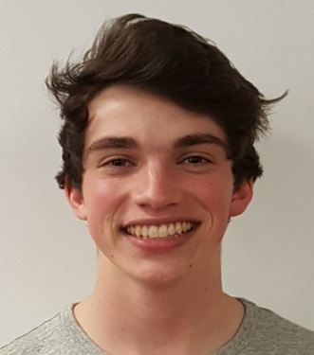
Max DeMaio
Max is going to be a junior at URI, majoring in Accounting and French. This is his fifth year working with Ledyard Parks and Recreation. He enjoys playing the guitar, chess, studying, and going to the gym (but he doesn’t even do cardio, but he DOES lift bro). He can be found after camp hanging out with Megan and KT and beating them in UNO and Mexican Train.
Counselors:
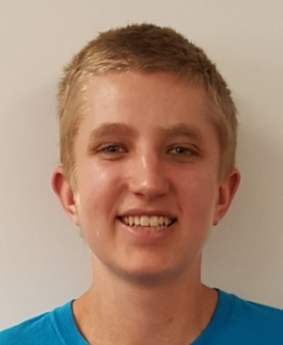
Matt Van Volkenburg
Matt has been working at summer camp for the past 4 summers. He is in his final semester of studying criminal justice at Three Rivers Community College. In his free time, he likes to fresh water fish. He also enjoy useless facts. For example, every time you lick a stamp you consume 1/10 of a calorie. Matt enjoys spending all time with a plastic coyote named Karen. Him and Karen met at Summer Playground 3 summers ago, and she has been a big part of the Colonels family ever since.
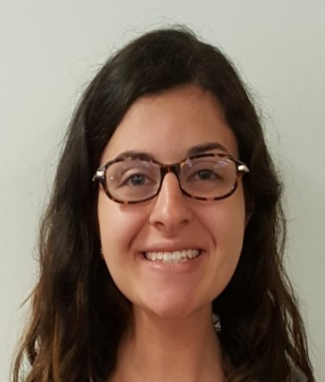
Lori Donovan
Hi There! My name is Lori Donovan and I love being a camp counselor! This is my 4th summer with Ledyard Park and Rec, and it gets more fun every summer! I am an Elementary Education and English major in the Honors College at SCSU and cannot wait to become a teacher someday. At camp you will find me most likely covered in glitter (literally!) doing crafts with my campers! Chalk drawing and playing dodgeball are some of my favorite activities too. I am looking forward to meeting you all soon!
Christine “CC” Simmons
My name is Christine Carrie Simmons but everyone calls me CC. I am 20 years old and this will be my third summer with Ledyard Parks and Recreation. I love being a staff member. My favorite game is knockout even though I'm most likely to be knocked out by a six year old. Just because you aren't good at something doesn't mean it's not fun. But I'm probably best well known for making a drawing for all my campers two summers ago. I love arts and crafts and if you aren't covered in glitter from head to toe on a weekly basis then you just aren't gaining the full camp counselor experience.

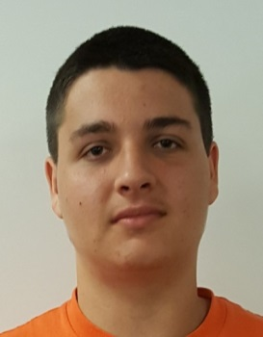
Wyatt Bagg
Wyatt Bagg is going to be a junior at Ledyard High School this fall. He is sixteen years old and loves history and sports, especially basketball. His hobbies include tennis, video games and playing basketball with his friends. His nickname is "the dribble God". He has been attending Ledyard Parks and Recreation camp since he was six years old. He volunteered last year and is looking forward to an amazing summer.
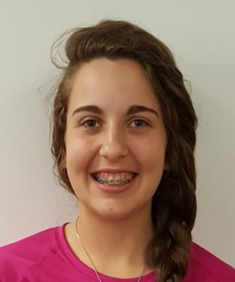
Erika deAndrade
Hello my name is Erika deAndrade! The wait is over until I get to see my cuties from last year! Everything has been leading up to these six weeks! I've been playing sports all year round, so no one will catch me in tag! My glue gun has been warming up and my glitter bottles have been refilled. I'm the baby of my family, so gaining twenty or so munchkins as younger brothers and sisters is all I could ask for! Let's just hope I don't have to scold them like an older sister.
Jaime Kelley
Jaime Kelley is a paraprofessional for Ledyard Public Schools. She has worked in the preschool program at Gallup Hill School for the last five years. She also works with older kids in the after school program, Ledyard Learners at Gallup Hill School. This is Jaime's first year working with Parks and Rec, and is looking forward to a great summer. Jaime has loved sharks since childhood, and Shark Week is one of her favorite things about summer!

