Popcorn Kernels Staff 2016:
Coordinator:
Megan Comstock
This is Megan’s 8th summer at Ledyard Parks and Recreation! She recently graduated from Endicott College with her bachelor’s in nursing and she is planning on pursuing her nursing career at the end of this summer. Therefore, this is her last year with Parks and Recreation. She will forever be remembered as the camp nurse, who dabbles in band aid distribution and ice pack popping. She is also known to be a professional snack opener, the Picasso of Playdoh, and just slightly taller than most of her preschool campers. She is hoping to make her last summer the best one yet!
Leaders:
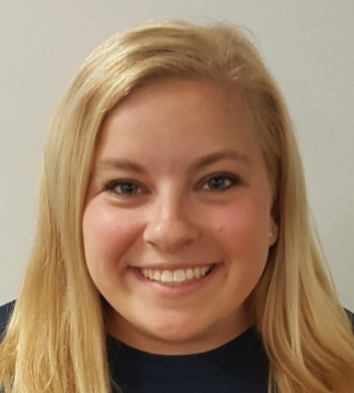
Katie “KT” Craig
KT Craig just graduated from Penn State with a degree in Education. She just spent the last full school year teaching 2nd graders (but let's be honest, much of their time spent together was making up raps, dancing and laughing at jokes). In her free time, KT enjoys crafting, watching Netflix, hiking and playing sports with friends. When not at summer camp, KT can be found at the beach, with Megan, or in Target. At camp, she loves to play water games and read stories. KT is very excited to work with you and your child this summer, and can't wait to make it the best summer yet!
Kira Ryan
K: ind and kid friendly!
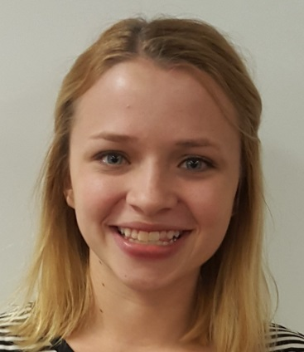
I: have been known to spontaneously burst into songs from the Frozen sound track
R:ainbow is my favorite color
A: m addicted to coffee and peanut butter

R:unning through the sprinkler is my favorite camp activity
Y: elling red light, green light takes practice
A: lways happy to bust out a craft
N: umber 4 is how many years I have been at camp
Counselors:
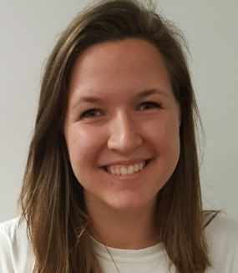
Jenna McHale
Jenna McHale is a second time staffer at Ledyard Parks and Rec and specializes in building ant hotels in the JWL sand pit and taking kids on a "space trip" on the swings. When not being chased in duck, duck goose, Jenna, because of her height, can be found lifting children onto monkey bars, retrieving lost toys from places above 5 feet and giving kids countless under dogs on the swings.
Jon Carver
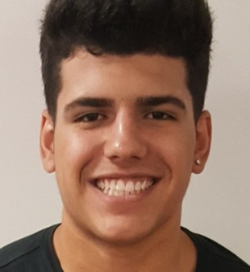
Shy is the last word used to describe me. I am a very outgoing person who can start a conversation with almost anyone. Some of my favorite parts of camp are water days, field trips, and lunch. The kids can't wait for the end of the week when they can go outside and cool off with a little fun in the water, and neither can I. The best part about the field trips is when campers fall asleep on the bus ride home knowing they had a great time…either that or my stories may be boring them to sleep? Lunch time is the best part of the day- it gives the kids the opportunity to recharge their excitement for the afternoon. This is my third year with the Ledyard Parks and Recreation, and every year I come back excited for a better summer.
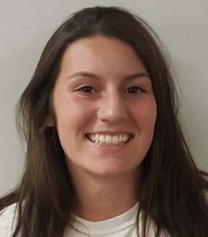
Delaney Gagnon
Delaney is a junior at Ledyard High School and LOVES sports. She runs track, plays basketball, and slays the game of soccer in net. She plans to use these skills to dunk on some preschoolers all summer long. Delaney is her happiest when she is wearing a fresh new pair of crocs. Camp is her most favorite place to be in the whole entire world, and she is excited to make some new little buddies (and eat popsicles all summer).
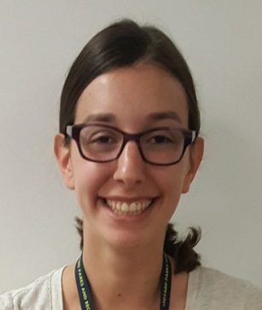
Sam Beacham
Samantha Beacham is a first time Parks and Rec employee. Though she's only worked with children for a few years, she feels that her expert knowledge of the popular show Parks and Recreation makes her extremely qualified for the position. Sam spends her free time raising awareness for the dying bee populations, practicing to beat Aaron in the alpha-volunteer obstacle course and reading picture books. She is known worldwide for being a Lego Expert and can't wait to build up her arm muscles pushing children on the swings.

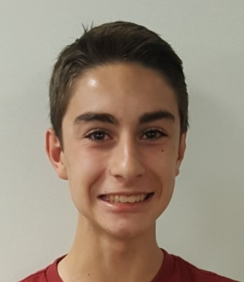
Aaron Barina
Aaron is currently a junior at Ledyard High School and this is his first summer working with Parks and Recreation. Last year, he was a volunteer at Popcorn Kernels and you could always find him in the tube on the playscape! Aaron was the winner of the MVV (Most Valuable Volunteer) Award and continues to train for the impending Alpha Volunteer Obstacle Course. He also was a big hit at the talent show with his impression of Vector from Despicable Me! Aaron is excited to be returning to camp this summer as a Playground Assistant so he can make the kids laugh.
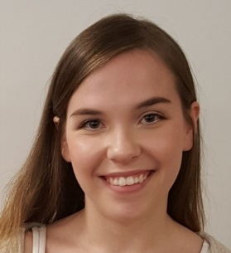
Mekaila Stefano
Mekaila graduated from LHS in 2015, and this will be her second year as a counselor with Ledyard Parks & Rec. Prior to this summer, Mekaila was even a camper herself. She currently attends Eastern Connecticut State University, but will be living in Florida as part of the Disney College Program during the upcoming semester. Mekaila hopes to create a little local Disney magic during her first Summer with the Popcorn Colonels!

