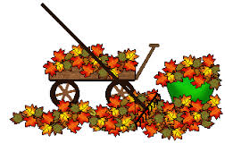

2014 LEDYARD SENIOR CENTER HARVEST BAZAAR
Saturday, October 25, 2015
9:00 a.m. to 2:00 p.m.
At the Ledyard Senior Center
12 Van Tassell Drive, Gales Ferry

We are so excited! Treasures to be discovered galore at the White Elephant Sale, vintage jewelry, books, puzzles, wood work, handicrafts, knickknacks, holiday items and all sorts of goodies. Feast on yummy breakfast sandwiches, made-to-order fluffy omelets, delectable baked boods, warm chili and cornbread, luscious Portuguese clam chowder and THE PERFECT HOT DOG.

See you there!!!

