Ledyard Parks and Recreation Summer Staff

COORDINATORS

Brittany Littlefield
Brittany is a senior at Eastern Connecticut State University and is majoring in Psychology in Children and Youth. This is her sixth year at Parks and Recreation, and her second year as Coordinator. During the school year she volunteers for the Sister to Sister Program though Windham High School. Brittany is thrilled for this year at camp, and is determined to make it the best year yet!

Claire Scott

Claire is a graduate of Central Connecticut State University and holds a Bachelor of Science in Music Education. She is the Assistant Director with the East Lyme High School Marching Band and is looking forward to starting her first full time music position at Oakdale Elementary School in Montville this fall. Claire enjoys working with students in and out of the music classroom. She started as a counselor for Ledyard Parks and Recreation in 2011. This will be Claire's fourth year working at Summer Playground and she is looking forward to working as a Coordinator this summer!


Jade Huguenot
Jade is an Ada Comstock Scholar at Smith College who studies Education and Government on a full scholarship. This is her third summer at Ledyard Parks and Recreation. She has worked with military children and in private preschools for a decade. She is a co-founder and event organizer for the Matthew Chew Memorial Scholarship for the Arts, and co-founded UConn Avery Point’s Global Café, a learning community. Her superlative last summer was “Little Miss Sunshine,”and she can’t wait to make this sunny summer as spectacular as possible for the kids!

The Popcorn Kernels Staff

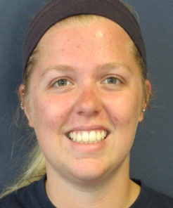

LEADER

Megan Comstock
Megan has been working for Parks and Rec for 5 years. She currently attends Endicott College in Beveny, MA for nursing as a junior. She enjoys playing soccer, solving puzzles, and hanging out with her friends and family.

ASSISTANTS

Allison Gardner
Ali has been working for Parks and Recreation for 4 years. She is attending Storrs, UConn and has been working at Lee’s Toys and Hobbies. She loves helping people and working with children. She has been babysitting for 7 years. Ali Enjoys spending time with her family and being outside in nature. Hiking is one of her favorite activities along with art, singing, writing, and eating ice cream.

Max DeMaio
Max is a senior at Ledyard High School. He will be attending URI in the Fall. This is his third year working with Ledyard Parks and Recreation. He enjoys running, playing his guitar, and hanging out with friends. Max likes working with kids and enjoys spending time with kids outside of camp, whether it’s a guitar lesson, babysitting, or even on the playground.

Kira Ryan
Kira has been working at Parks and Recreation for 3 years as well as volunteering for a year. She enjoys playing tennis and being outside. Kira is going to college to study Elementary Education.

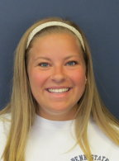
Katelyn Craig
Katelyn is a junior at Penn State University who is majoring in Elementary Education. She attended the Ledyard Parks and Recreation summer program as a child and absolutely loved it, and now this is her first year as a Playground Assistant! She loves cats, her favorite sport is lacrosse, and she loves to do crafts.

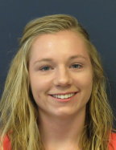
Brooke Scahill
Brooke is a senior at Ledyard High School. She has volunteered with Ledyard Parks and Recreation for the past two years, and this will be her first summer as a Playground Assistant! She enjoys playing soccer, lacrosse, and running. She is very creative and loves making crafts with the children!

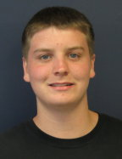
Mitchell Santiago
Mitchell is a junior at Ledyard High School, where he plays football with the high school team. He has volunteered for Ledyard Parks and Recreation for the past two years, and this will be his first year as a Playground Assistant! He is energetic and cheerful, and loves water days with the kids!

The Colonels Staff

LEADERS
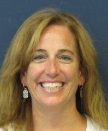
Diane McCarthy
Diane is a mother of a 5 year old son, Kadin. During the school year she is a behaviorist at the Regional Multicultural Magnet School in New London, CT. This is Diane’s 8th summer with Ledyard Parks and Recreation as an instructor. She has a Bachelor’s Degree in Elementary Ed from CCSU (’92) and a MA Degree in Counseling Psychology from JFKU (’04). Diane has over 20 years of experience working with small children.

Krista Grimes
During the school year, Krista works for Fields Memorial School in Bozrah as a special education paraprofessional. This is her 5th year working for Parks and Rec and her 2nd year as a leader. During her leisure time, she likes to go to the beach and concerts. Krista also likes to cook!

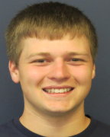
Greg Knight
Greg has been working at Parks and Rec for 4 years. He’s a huge fan of the New York Giants and loves to play sports like football and Frisbee. He goes to UConn where he is studying to become a math teacher. His favorite food is tacos and he loves to cook. He is looking forward to being outside for the summer!

ASSISTANTS
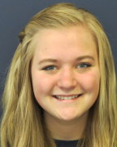
Amy Knight
Amy is going to be a freshman at the University of Pittsburgh in the fall and is returning to Parks and Rec for the fourth year. She was a member of the Ledyard High School swim team for 3 years and plans to swim in college. She loves working with kids and plans to major in maternity nursing in college.



Dylan Bagg
Dylan is a recent graduate of Ledyard High School. He is continuing his education at Three Rivers Community College. This is his 2nd year working at Parks and Rec. Dylan enjoys being outside and fishing.

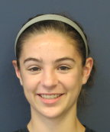
Emme Cronin
Emme is a senior at Ledyard High School. This is her 3rd year with Ledyard Parks and Recreation and she also volunteered for a year. Emme is Ledyard’s first girl to win a varsity match in the sport of wrestling. She is also the captain of the cross country team and she runs track and field. Emme plans to study psychology in college.

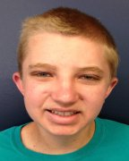
Matt VanVolkenburg
Matt is a recent graduate of Ledyard High School. This is his second year at Parks and Recreation. In the fall he will be going to Three Rivers Community College to study criminal justice. He is excited for camp and is willing to make this the best summer for the kids yet!

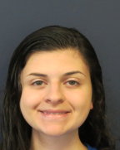
Lori Dononvan
Lori will be a freshman at SCSU. She loves summer camp and is very excited to start camp again this year! She loves playing 4 square and doing arts and crafts. She cannot wait to have more fun with the Ledyard Parks and Rec summer program.

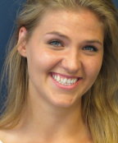
Morgan Stoodley
Morgan is a junior at a college in California, studying Elementary Education. She is a native Ledyardite. She loves working with children so much that all of her work experience has been with kids; she has been a tutor, a Sunday School teacher, and a babysitter. She looks forward to playing sports, reading stories, and singing songs with the kids this summer!


Christine Simmons
Christine just finished her freshmen year at Keene State College, and will be a sophomore at UConn in the fall with a double major in Elementary Education and Music. She will be participating in the swim club at UConn. She has experience volunteering for the nursery school with her church, and as a counselor at Vacation Bible School for three years in a row. She loves singing, hiking, and swimming, and looks forward to her first year as a Playground Assistant at Ledyard Parks and Recreation!

The Super Colonels Staff

LEADERS
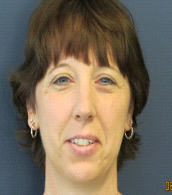
Ann-Marie Booth
Ann-Marie is a mother of five. She works at Ledyard High School as a Para-Professional. Ann-Marie has fifteen years of experience in Playground Programs. She enjoys cooking and reading. She also loves working with children as well as reading, cooking, and baking. This is Ann-Marie’s 2nd year working at Ledyard Parks and Recreation.
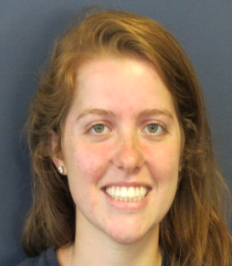
Jillian Comstock
Jillian is a senior nursing student at the University of Saint Joseph and will be graduating next year with a bachelor’s in nursing. This will be Jill’s 6th year as a counselor and her 2nd as a leader. Jill loves to do Arts and Crafts as well as vacationing to South Carolina.


ASSISTANTS

Ben Bruciati
Ben has worked as a volunteer as well as a counselor. He plays soccer and ran track. He goes to UConn as a civil engineer major. Ben runs a track club at UConn.



Dayton Bagg
Dayton has worked for Ledyard Parks and Rec for 3 years. He attended camp as a kid for 8 years. Dayton enjoys sports and loves the outdoors. He is currently enrolled at UConn as a Wildlife Management major.


Jessica Monday
Jessica is a sophomore at Colby-Sawyer College in New Hampshire. She is studying athletic training with a pre-physical therapy tract and a coach’s certificate. She has been working at camp for 3 years going on her 4th year. This will be her 1st year as a leader. She attended Ledyard Parks and Recreation Summer camp as a kid. Jess is looking forward to this coming summer and is ready to introduce new activities. Here’s to a great summer!

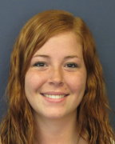
Patricia Elliot
Trish is a sophomore at Keene State College studying psychology and aiming to work with children when she achieves her degree. This is her 2nd year working at Ledyard Parks and Rec and she looks forward to working here for years to come. Trish can’t wait to see all the returning campers again and to meet many new faces for a great summer!

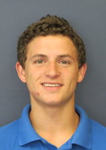
Patrick Gallagher
Patrick just completed his first year at Three Rivers Community College and is on his way to Eastern CT State University. He is majoring in Sports Management, and minoring in Coaching. He was a basketball coach for Upward Basketball, and he worked as a baseball camp counselor for the past four summers. He is an avid basketball and baseball player, and enjoys staying active.

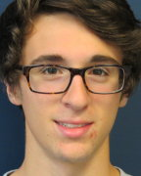
Aaron Norcia
Aaron is a junior at Ledyard High School where he stays active as a peer mediator; a cross-country captain; a singer with the men’s acapella group The Final Cut; and as an honors student. He has been working with the Ledyard Parks and Recreation Summer Playground as a Volunteer for the past two years. He is an active volunteer with the Reading Kids program at the Bill Library, and a member of the Ledyard Carolers.

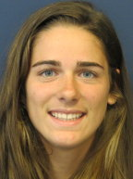
Francesca Francischelli
Francesca is a senior at Ledyard High School who will be attending UConn next year as an Elementary Education major. This will be her first summer at the Ledyard Parks and Recreation summer playground program! She has played softball all four years of her high school career, and is a former reading volunteer for 2nd graders. She loves children, and can’t wait to play running and water games with the kids.

