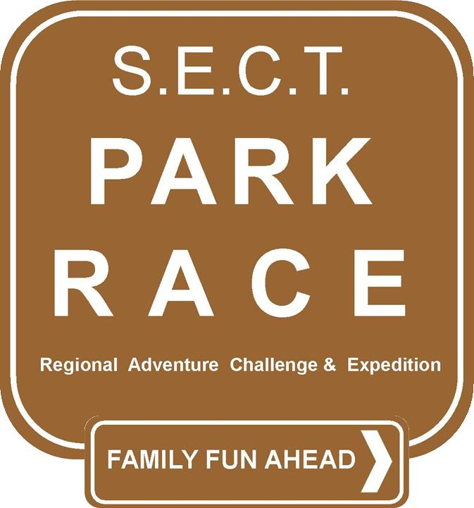
Park RACE
Regional Adventure Challenge & Expedition
Get your friends and family members outdoors for an exciting summer of new adventures and activities in parks surrounding you in the 1st Annual Park Regional Adventure Challenge & Expedition (RACE). Register your team and receive a passport that grants you and your team members admission into a number of pre-selected parks in SECT throughout the summer. Each page of the RACE passport contains details on a park activity for your team to complete. Some activities require teams to complete a challenge on a specific date, and others allow teams to complete challenges at times of their choosing. Complete activities and gather stamps in your passport at each of the parks to earn chances for great outdoor gear prizes! A giant kick-off party and a big finale mark the start and end of the challenge! You won't want to miss out on this exciting adventure!
Register now!
Rules
- Teams can contain from 2-6 members (families, friends, or co-workers), at least one team member must be an adult.
- Sign up FREE and get your passport at the Kick-off event or from your local parks and recreation department.
- Teams earn one prize drawing entry for each activity completed. The more you do, the better your chances at winning a great prize!
- Teams that complete all challenges receive five (5) bonus entries.
- Winners must be present at the final event to claim prizes.
Prizes
Bicycle Emergency Kit
Family Membership in Groton Community Boating Club
Paintball Party for up to 6
Check back soon for a list of more great prizes!
Events
Small Boat Day at Esker Point Beach - 900 Groton Long Point Rd, Noank, Saturday, May 31, 2014 10am - 2 pm
Colonel Ledyard Park Hike - 4 Blonders Blvd, Ledyard, Anytime Challenge
Stenger FarmHike or Ride - 128 Clark Lane, Waterford, Anytime Challenge
Emily�s Place at Riverside Park Scavenger Hunt - Crystal Avenue and Adelaide Street, New London, Anytime Challenge
Washington Park Exercise Circuit - 283 Meridian Street, Groton, Anytime Challenge
Stenger Farm - 305 Great Neck Rd., Waterford, Anytime Challenge
Camp Oakdale Letterboxing- 176 Meetinghouse Lane, Oakdale, Sunday, June 8, 2014 9am to 2pm
Airline Trail Spur Scavenger Hunt - 215 Connecticut 16, Colchester, Anytime Challenge
Mystic River Park Family Movie Night - Cottrell St, Stonington (Mystic), Friday Nights - TBD
McCook Point ParkFinale Movie, Prizes & Campout- 8 Atlantic Street, Niantic CT, Friday, August 29, 2014
Sponsors and Donors
City of Groton Parks and Recreation
Colchester Recreation
Denison Pequotsepos Nature Center
East Lyme Parks and Recreation
Groton Parks and Recreation
New London Recreation
Ledyard Parks and Recreation
Montville Parks and Recreation
Project Oceanology
Stonington Recreation
Waterford Recreation and Parks
EVENT DETAILS

Esker Point Beach
900 Groton Long Point Rd, Noank
Saturday, May 31, 2014 10am - 2 pm (rain date Sunday, June 1)

Enjoy small Boat Day by trying out a kayak, sailboat, paddleboard, or sliding seat shell and getting information from CT DEEP about safe boating and keeping our waters clean. All skill levels are welcome and life jackets are provided. For more information contact Groton Parks and Recreation at 860-536-5680 or www.grotonrec.com/smallboatday.asp.
Your Challenge: All team members must try out at least one boat to complete the challenge! Seek out a GP&R staff member to have passport validated.

Camp Oakdale
176 Meetinghouse Lane, Oakdale
Sunday, June 8, 2014 9am to 2pm

Discover Letterboxing! Come anytime during the event hours to find one or all of the letterboxes. Bring plenty of water and your lunch, plus a compass and letterbox kit if you have them. Contact: Montville Parks & Recreation Department 860-848-3030 x321 or Chris Lawton at Trailblazed72@gmail.com.
Your Challenge: Find letterboxes and have a staff member stamp your passport.

Mystic River Park
Cottrell St, Stonington (Mystic)
Friday Nights – TBD

Bring your blankets, beach chairs and picnic dinners for a family-friendly movie that begins at sundown (about 8:15 pm). Come early to reserve your spot! Many thanks go to our partner, the Mystic River Park. For more information or a list of movies and dates, contact Stonington Human Services at 860-535-5015.
Your Challenge: Attend a Friday Family Movie Night and get a staff member to stamp your passport.

Airline Trail Spur
215 Connecticut 16, Colchester
Anytime Challenge

Take a hike, run, or bike along the Airline Trail Spur and enjoy nature as it’s intended. The Airline Trail Spur follows the old Colchester Railway bed and connects to the Airline Trail. Remember to dress appropriately for the woods to protect from ticks. Contact: Colchester Parks and Recreation Department at 860-537-7297.
Your Challenge: Find an item that starts with the each letter in the words, (Park RACE) (Ex. “A” is for Acorn). Take a picture of your group with the items you found and place the photo in your passport.

Colonel Ledyard Park Hike
4 Blonders Blvd, Ledyard
Anytime Challenge

Go on an adventure hike to find a secret destination and “I Spy” items along the way. Get challenge clues and your “I Spy” list by calling the Ledyard Parks and Rec Office at 860-464-9112 or at www.ledyardrec.org.
Your Challenge: Take a picture of your team at the secret destination. Place the photo in your passport.

Emily’s Place at Riverside Park
Crystal Avenue and Adelaide Street, New London
Anytime Challenge

Visit the new playground known as Emily’s Place while you overlook the beautiful Thames River, take a walk down the river side path, play basketball, or have a picnic. Download a scavenger hunt list at www.newlondrec.com or stop in our office at 120 Broad Street. Call New London Recreation Department at 860-447-5230 with any questions.
Your Challenge: Complete the scavenger hunt, take a picture of your group with scavenger hunt items near Emily’s Place and place the photo in your passport.

Stenger Farm
128 Clark Lane, Waterford
Anytime Challenge

Walk or mountain bike through Stenger Farm and explore the many trails in the 100 acre property. Dress appropriately for going through woods and fields to protect from ticks. Contact Waterford Recreation and Parks at 850-444-5881.
Your Challenge: Take a picture of your team on the fishing dock and place the photo in your passport.

Washington Park
283 Meridian Street, Groton
Anytime Challenge

Introduce your team to the 9-piece outdoor fitness circuit (near the tennis courts). Dress to exercise! All the machines have instructions on how to use them. Contact: City of Groton Parks and Recreation at 860-446-4128 or pr@cityofgroton.com.
Your Challenge: Take photos of team members on their favorite machines and place photos in your passport.

McCook Point Park
8 Atlantic Street, Niantic CT
Friday, August 29, 2014

This is the Finale event for the Park RACE and prize drawings will be held! Confirm your attendance for the Movie Night and Family Camp Out with East Lyme Parks and Recreation at 860-739-5828 prior to August 28th to get a camp site. Bring your tent, sleeping bags, food and necessary items to enjoy a nice night outdoors. A movie will be shown at 7:30 and backyard games and activities will be available to use before sunset.
Your Challenge: Enjoy activities and entertainment and sleep overnight in a tent with your team.

